**Title:** An examination of vertebrae morphological features in adult Florida manatees for better maneuverability in an aquatic environment

**Introduction**

Mammalian development has diverted extensively that some species appear very different from each other. For example, a fruit bat and blue whale both belong to the mammalian class but differ in the places they inhabit, diets, and overall morphology. Even species that are more closely related such as humans and chimpanzees have very noticeable differences in their morphology but are distinct from each other. Because of this, studies are performed on the functionality of these different morphological features that are present almost exclusively in one species but not others.

The Florida manatee (*T. Manatus)* is one species that has a very distinct developmental pattern that is unique among mammals. As an aquatic species, much of their survival depends on how well they may navigate a 3-dimensional space and this is most evident in the characteristics of the manatee vertebrae. The structure of a manatee vertebrae is indicative of a very specific kind of undulation in water that will differ from other mammals due to their body structure and environmental interactions. A developmental strategy that may have occurred in manatee vertebrae is the strengthening of specific attributes that assist in the maneuverability of an aquatic species (Ingle and Porter, 2020).

One attribute that may occur differently in manatees than other mammals is that of the orientation of vertebrae and how strong they are. The vertebrae orientation of mammals seems to be influenced by the environment they inhabit. For instance, speeds of dolphins (*D. Delphis)* is slightly benefited from strengthin the dorsoventral and rostro-caudal midpoints of the vertebral column as there is increased yield strength and stiffness at these orientations to aid in flexion of their spines to move (Long et al, 1997). In manatees, the effect could be similar to that of dolphins.

This article aims to find what developmental adaptations have occurred in manatee vertebrae to assist in their maneuverability in an aquatic environment. This will be done by examining several features of the manatee vertebrae such as comparing the specific orientations of vertebrae and their yield strength (understand stress to permanent deformation), stiffness (resistance to deformation), and toughness (ability to absorb energy). Presumably, some orientations of the vertebrae will have a higher mechanical load than that of others due to the need to flex the spine in certain waves to move. By examining these features of the manatee vertebrae, researchers will be able to better understand the specific adaptations manatees have in response to their aquatic environments.

**Methods**

Data was collected from a sourced article by Ingle and Porter published in 2020. Their research on the vertebrae of the Florida Manatee included the necropsies of 20 manatees (N=20). Of the data gathered, a focus was placed on the adult manatee samples that were gathered as their development is complete and the full spectrum of their physiology can be presented.

Similarly for the vertebrae, specific pieces of information were isolated from the original data. Here, we used the adult yield strength, stiffness, and toughness to adequately see what parts of the spine had the best resistance to stress and deformation. Likewise, the orientation of the vertebrae were also taken into account as these can be used to locate the strongest areas of the spine. Orientation consisted of the dorsoventral (DV), mediolateral (ML), and rostrocaudal (RC). Below are graphs depicting the yield strength, stiffness, and toughness of the vertebrae at various orientations.

**Results**

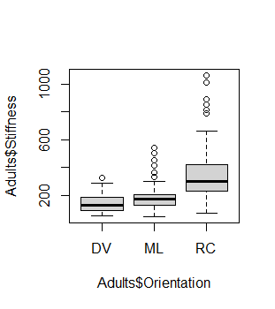

**Figure 1 (Stiffness vs Orientation):** This figure depicts the orientation of the adult vertebrae regions versus the adult vertebrae stiffness. The rostrocaudal region of the spine has the highest stiffness by a marginal amount compared to the mediolateral and dorsoventral regions of the vertebrae. The t-test for this table indicates that there is a significant relationship between the orientation of the vertebrae and its stiffness (t = 25.23).

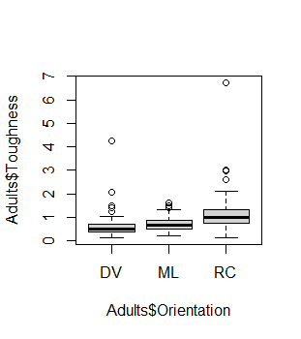

**Figure 2 (Toughness vs. Orientation):** This figure shows the relationship between the vertebrae orientation and its toughness. The rostrocaudal region exhibits the highest toughness compared to the other regions of the spine. The toughness of the dorsoventral and the rostrocaudal do see some outliers in the grouping, however, most are concentrated in the ranges of 0.5 and 1.1 respectively. The t-test for this graph shows that the orientation of the vertebrae does have a significant effect on its toughness (t = 22.879).

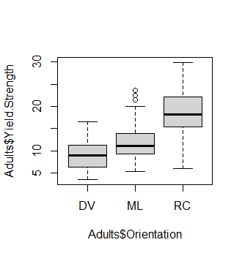

**Figure 3 (Strength vs Orientation):** This figure shows the adult manatee vertebrae strength and orientation. The rostrocaudal region has the highest strength but also the largest range of the other regions. The t-test value indicates that orientation does affect the vertebrae strength to some extent (t= 39.839).

**Discussion**

This paper examined the morphological features of the Florida manatee in order to better understand the developmental patterns in response to an aquatic environment. To illustrate the morphological changes that occurred in the manatees, an examination was conducted on the vertebrae of adult manatees. The orientation of manatee vertebrae was valued as an indicator of undulatory force and maneuverability in a 3-dimensional environment as specific orientations may have higher strengths than others due to the various movement patterns performed by manatees. According to the data collected, there is a correlation between the orientation of the vertebrae and the various strength factors associated with bone.

The values reported in the data are indicative of a positive correlation between the orientation of vertebrae and the associative strength factors such as yield strength, stiffness, and toughness. This is seen in the t-test values reported in each of the figures. The results show the rostrocaudal orientation of the manatee vertebrae to be the most sturdy in all the values chosen. This is in line with the hypothesis that some orientations of the vertebrae will yield higher sturdiness than others. Likewise, distribution of strong vertebral characteristics among manatee populations is seen not only in the individual vertebrae but also localized development in different regions of the spine (Buchholtz et al. 2007).

In a follow-up study performed on the vertebrae of dolphins, the results of which closely resemble the ones indicated in this study. The vertebral bone orientation of the rostrocaudal region also had the highest measurements of mechanical properties in yield strength, stiffness, and resilience (Ingel and Porter, 2022). Though the purpose of the high mechanical properties may be slightly different between dolphins and manatees, the overall implication is that the rostrocaudal orientation seems to be a key point of development for aquatic mammals in their swimming ability.

These findings are indicative of the morphological responses made by aquatic mammals to their environment. In a three-dimensional environment, the need for undulating movement is great and requires a vertebral column that is capable of high maintenance due to it providing the main source of motion for aquatic animals such as the Florida manatee. High mechanical strength at specific orientations such in the rostrocaudal orientation supports this idea. Though the overall effect of the environment leading to this development is not entirely known, the data provided still suggests a need for high mechanical strength in manatee vertebrae for sustained movement.

**Conclusion**

In this paper, it was theorized that specific orientations of the manatee vertebrae would have a greater yield strength, stiffness, and toughness as a developmental response to the sustained undulating motion required in an aquatic environment. It is evident from the results that vertebrae resistance to deformation and ability to absorb energy is highly influenced by orientations where specifically the rostrocaudal orientation is highest of these characteristics. While specific environmental influences were not explored in this study, the adaptations for an aquatic lifestyle are quite evident in the need for a strong vertebral column.

**Work Cited**

1. Alvarez-Alemán, A., García Alfonso, E., Powell, J. A., Jacoby, C. A., Austin, J. D., & Frazer, T. K. (2021). Causes of Mortality for Endangered Antillean Manatees in Cuba. *Frontiers in Marine Science*, *8*.<https://www.frontiersin.org/articles/10.3389/fmars.2021.646021>
2. Buchholtz, E. A., Booth, A. C., & Webbink, K. E. (2007). Vertebral anatomy in the Florida manatee, Trichechus manatus latirostris: A developmental and evolutionary analysis. *The Anatomical Record*, *290*(6), 624–637.<https://doi.org/10.1002/ar.20534>
3. Dumont, M., Laurin, M., Jacques, F., Pellé, E., Dabin, W., & de Buffrénil, V. (2013). Inner architecture of vertebral centra in terrestrial and aquatic mammals: A two-dimensional comparative study. *Journal of Morphology*, *274*(5), 570–584.<https://doi.org/10.1002/jmor.20122>
4. Ingle, D. N., & Porter, M. E. (2020). Developmental changes in bone mechanics from Florida manatees (Trichechus manatus latirostris), obligate swimming mammals. *Journal of Experimental Biology*, *223*(6), jeb213009.<https://doi.org/10.1242/jeb.213009>
5. Ingle, D. N., & Porter, M. E. (2022). Vertebral Trabecular Bone Mechanical Properties Vary Among Functional Groups of Cetaceans. *Integrative Organismal Biology*, *4*(1), obab036.<https://doi.org/10.1093/iob/obab036>
6. Lightsey, J. D., Rommel, S. A., Costidis, A. M., & Pitchford, T. D. (2006). METHODS USED DURING GROSS NECROPSY TO DETERMINE WATERCRAFT-RELATED MORTALITY IN THE FLORIDA MANATEE (TRICHECHUS MANATUS LATIROSTRIS). *Journal of Zoo and Wildlife Medicine*, *37*(3), 262–275.<https://doi.org/10.1638/04-095.1>
7. Long, J. H., JR, Pabst, D. A., Shepherd, W. R., & Mclellan, W. A. (1997). Locomotor Design Of Dolphin Vertebral Columns: Bending Mechanics And Morphology Of Delphinus Delphis. *Journal of Experimental Biology*, *200*(1), 65–81.<https://doi.org/10.1242/jeb.200.1.65>
8. Moore, J. C. (1951). The Status of the Manatee in the Everglades National Park, with Notes on Its Natural History. *Journal of Mammalogy*, *32*(1), 22–36.<https://doi.org/10.2307/1375409>